**The code below is a symbol of advancement. It was able to:**

1. **Create a new folder in the path D:\Documents in case it was non existent**
2. **Create a new file 1.txt incase it was non existent**
3. **Log in data into the text file.**
4. **Incase there was data in the log file it was able to append additional data into the log file.**

**The following code printed for all the default folders except for the downloads folder:  
It displayed for :**

1. **Desktop folder**
2. **Documents folder**
3. **Videos folder**
4. **Pictures folder**
5. **Music folder**
6. **Common Desktop folder**

**It didn’t display correctly for:**

**1. Downloads folder**

1. #include <stdio.h>
2. #include <windows.h>
3. #include <shlobj.h> // Include the header for SHGetFolderPath
4. // Function prototypes
5. void listDirectoriesAndFilesInRoot(const wchar_t *path, FILE *logFile);
6. void processDefaultFolders(FILE *logFile);
7. int main()
8. {
9. // Variable to store the path of the current code file
10. wchar_t currentCodeFilePath[FILENAME_MAX];
11. // Get the path of the current executable (the code file)
12. GetModuleFileNameW(NULL, currentCodeFilePath, FILENAME_MAX);
13. // Extract the directory path by removing the file name from the path
14. const wchar_t *lastBackslash = wcsrchr(currentCodeFilePath, L'\\');
15. currentCodeFilePath[lastBackslash - currentCodeFilePath + 1] = L'\0';
16. // Get the path of the 'Documents' folder using SHGetFolderPath
17. wchar_t documentsFolderPath[FILENAME_MAX];
18. if (SHGetFolderPathW(NULL, CSIDL_PERSONAL, NULL, 0, documentsFolderPath) != S_OK)
19. {
20. // Print an error message if getting the folder path fails
21. wprintf(L"Failed to get 'Documents' folder path.\n");
22. return 1; // Return with an error code (1) to indicate failure
23. }
24. // Print the current directory and the code file's location
25. wprintf(L"Listing directories and files in %ls\n(Current Code File Location: %ls)\n", documentsFolderPath, currentCodeFilePath);
26. // Variable to store the log file name
27. wchar_t logFileName[FILENAME_MAX];
28. // Create the log file name using the current directory path
29. _snwprintf(logFileName, FILENAME_MAX, L"%lsbin\\1.txt", currentCodeFilePath);
30. // Check if the 'bin' folder exists, if not, create it
31. wchar_t binFolderPath[FILENAME_MAX];
32. _snwprintf(binFolderPath, FILENAME_MAX, L"%lsbin", currentCodeFilePath);
33. if (!CreateDirectoryW(binFolderPath, NULL))
34. {
35. DWORD error = GetLastError();
36. if (error != ERROR_ALREADY_EXISTS)
37. {
38. // Print an error message if the folder creation fails
39. wprintf(L"Failed to create 'bin' folder: %ls\n", binFolderPath);
40. return 1; // Return with an error code (1) to indicate failure
41. }
42. }
43. // Open the log file in "append" mode (add data to the existing file)
44. FILE *logFile = _wfopen(logFileName, L"a");
45. if (logFile)
46. {
47. // Call the function to list directories and files in the specified path (Documents folder)
48. listDirectoriesAndFilesInRoot(documentsFolderPath, logFile);
49. // Call the new function to iterate through the default folders and append data to the log file
50. processDefaultFolders(logFile);
51. // Close the log file after writing the data
52. fclose(logFile);
53. // Print a success message with the log file name
54. wprintf(L"Successfully logged to %ls.\n", logFileName);
55. // Read and print the contents of the log file to the console
56. wprintf(L"\nLogged Contents:\n");
57. FILE *readLogFile = _wfopen(logFileName, L"r");
58. if (readLogFile)
59. {
60. wchar_t buffer[512];
61. while (fgetws(buffer, 512, readLogFile))
62. {
63. wprintf(L"%ls", buffer);
64. }
65. fclose(readLogFile);
66. }
67. else
68. {
69. // Print an error message if reading the log file fails
70. wprintf(L"Failed to read %ls.\n", logFileName);
71. }
72. }
73. else
74. {
75. // Print an error message if opening or writing to the log file fails
76. wprintf(L"Failed to open or write to %ls.\n", logFileName);
77. }
78. return 0; // Return with a success code (0) to indicate successful execution
79. }
80. // Function definition to list directories and files in the specified path
81. void listDirectoriesAndFilesInRoot(const wchar_t *path, FILE *logFile)
82. {
83. // Variables for handling file enumeration in the specified path
84. wchar_t searchPath[MAX_PATH];
85. WIN32_FIND_DATAW findFileData;
86. // Create the search pattern for the specified path
87. _snwprintf(searchPath, MAX_PATH, L"%s\\*", path);
88. // Find the first file in the specified path
89. HANDLE hFind = FindFirstFileW(searchPath, &findFileData);
90. // Check if file enumeration is successful or not
91. if (hFind == INVALID_HANDLE_VALUE)
92. {
93. // Print an error message if enumeration fails
94. wprintf(L"Error finding directories and files in: %ls\n", path);
95. return; // Return from the function
96. }
97. // Collect directories and non-directory files separately
98. wprintf(L"Directories:\n");
99. do
100. {
101. // Check if the current item is a directory
102. if (findFileData.dwFileAttributes & FILE_ATTRIBUTE_DIRECTORY)
103. {
104. // Exclude '.' and '..' directories from the listing
105. if (wcscmp(findFileData.cFileName, L".") != 0 && wcscmp(findFileData.cFileName, L"..") != 0)
106. {
107. // Print the directory name to the console
108. wprintf(L"Directory: %ls\n", findFileData.cFileName);
109. // Log the directory name to the log file
110. fwprintf(logFile, L"Directory: %ls\n", findFileData.cFileName);
111. }
112. }
113. } while (FindNextFileW(hFind, &findFileData) != 0);
114. // Close the handle to release resources
115. FindClose(hFind);
116. // Reopen the handle to find non-directory files
117. hFind = FindFirstFileW(searchPath, &findFileData);
118. // Collect non-directory files
119. wprintf(L"Files:\n");
120. do
121. {
122. // Check if the current item is not a directory (i.e., a file)
123. if (!(findFileData.dwFileAttributes & FILE_ATTRIBUTE_DIRECTORY))
124. {
125. // Print the file name to the console
126. wprintf(L"File: %ls\n", findFileData.cFileName);
127. // Log the file name to the log file
128. fwprintf(logFile, L"File: %ls\n", findFileData.cFileName);
129. }
130. } while (FindNextFileW(hFind, &findFileData) != 0);
131. // Close the handle to release resources
132. FindClose(hFind);
133. }
134. void processDefaultFolders(FILE *logFile)
135. {
136. // Define an array of folder CSIDLs (constants) along with their descriptions
137. const int defaultFolderCSIDLs[] = {
138. CSIDL_DESKTOP, CSIDL_PERSONAL, CSIDL_MYVIDEO, CSIDL_MYPICTURES, CSIDL_MYMUSIC, CSIDL_COMMON_DESKTOPDIRECTORY, 0x001A
139. };
140. // Define the corresponding folder descriptions
141. const wchar_t *defaultFolderDescriptions[] = {
142. L"This is the Desktop folder:",
143. L"This is the Documents folder:",
144. L"This is the Videos folder:",
145. L"This is the Pictures folder:",
146. L"This is the Music folder:",
147. L"This is the Common Desktop folder:",
148. L"This is the Downloads folder:"
149. };
150. // Iterate through the array and call listDirectoriesAndFilesInRoot for each folder
151. for (int i = 0; i < sizeof(defaultFolderCSIDLs) / sizeof(defaultFolderCSIDLs[0]); i++)
152. {
153. // Get the path of the default folder using CSIDL
154. wchar_t folderPath[MAX_PATH];
155. if (SHGetFolderPathW(NULL, defaultFolderCSIDLs[i], NULL, 0, folderPath) == S_OK)
156. {
157. // Add the folder description to the log file
158. fwprintf(logFile, L"\n\n%s\n\n", defaultFolderDescriptions[i]);
159. // Call listDirectoriesAndFilesInRoot for each default folder
160. listDirectoriesAndFilesInRoot(folderPath, logFile);
161. }
162. else
163. {
164. // Print an error message if getting the folder path fails
165. wprintf(L"Failed to get default folder path for CSIDL %d.\n", defaultFolderCSIDLs[i]);
166. }
167. }
168. }

I wanted to access the default folders. Now suppose that normally in every computer, by default there is a downloads, document, videos, pictures, music and desktop folders. In most operating systems, especially Windows, macOS, and Linux distributions, there are standard default folders commonly found in the user's home directory. These folders are created by the system to organize specific types of files and are commonly known as "special folders" or "user folders."  
The actual names of these folders might vary slightly depending on the operating system and its language settings. For example, on some systems, "Documents" might be called "My Documents" or "Documents" in the native language

It's important to note that while these default folders are commonly present in most systems, users can still create, rename, or delete folders to suit their preferences or organizational needs. Additionally, the availability and names of these folders can differ in various operating systems and versions.

To access the standard default folders without using hardcoded paths, you can use platform-specific functions that provide the paths to these special folders programmatically. In Windows, you can use the SHGetFolderPath function to get the paths to special folders. On macOS, you can use NSSearchPathForDirectoriesInDomains, and on Linux, you can use XDG Base Directory Specification.

Here's how you can modify the code to access the "Downloads" folder on Windows using SHGetFolderPath  
Added the #include <shlobj.h> header to include the necessary declarations for using the SHGetFolderPath function.  
Modified the main() function to use SHGetFolderPath to get the path of the "Downloads" folder:  
The SHGetFolderPath function retrieves the path of a special folder identified by a CSIDL (Constant Special Item ID List) value. In this case, CSIDL_PERSONAL is used, which represents the "My Documents" folder on Windows, where the "Downloads" folder is often located.  
After retrieving the path using SHGetFolderPath, the code appends "\Downloads" to the path to form the full path to the "Downloads" folder. The rest of the code then uses this dynamically obtained path to list directories and files in the "Downloads" folder.  
Using this approach allows the code to access the "Downloads" folder without relying on hardcoded paths, making it more flexible and portable across different systems and users.

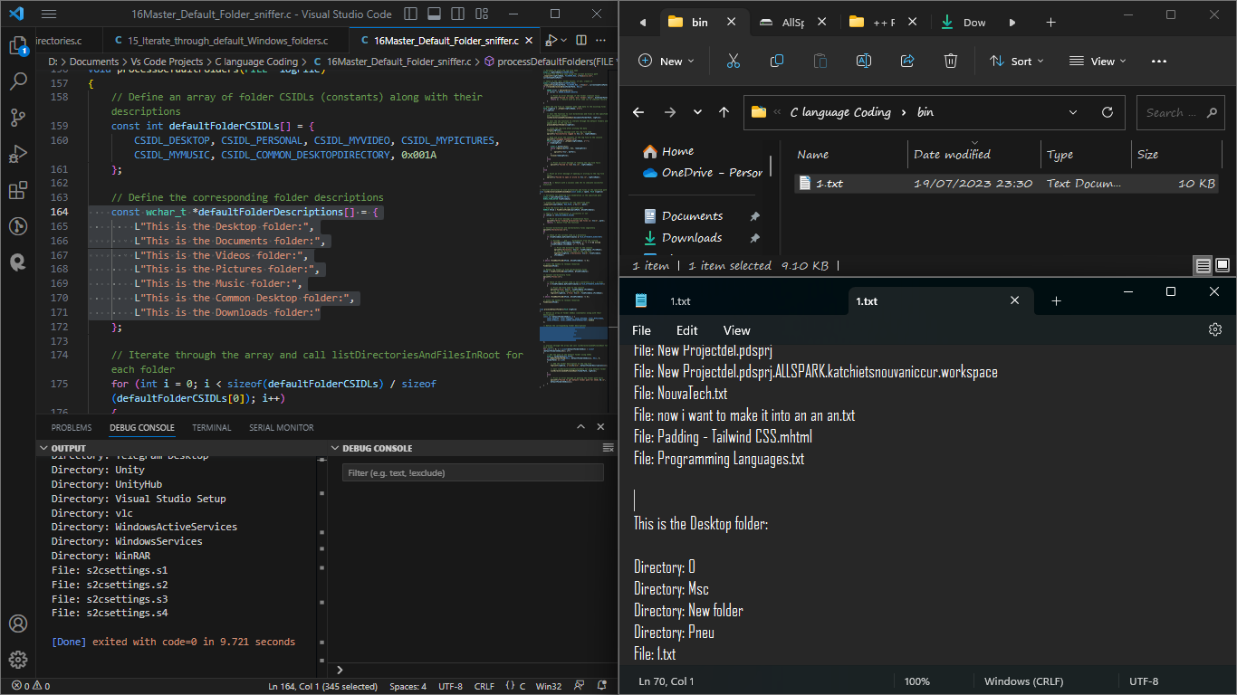

**LIMITATIONS OF PREVIOUS VERSIONS:**

Hardcoded Path: The code currently lists the directories and files in the "D:\Documents" folder. To make it more flexible and work on any system, you can replace the hardcoded path with a dynamic path using the SHGetFolderPath function.

Folder Enumeration: The listDirectoriesAndFilesInRoot function currently uses the "D:\Documents" folder directly for enumeration. Instead, you should use the path parameter that's passed to the function.

Incorrect Folder Enumeration: The listDirectoriesAndFilesInRoot function doesn't properly use the provided path for enumeration. It uses a hardcoded path instead. To fix this, you need to replace (wchar_t *)L"D:\\Documents\\*" with (wchar_t *)path in both places.

Incorrect Log Folder Path: In the processDefaultFolders function, when calling listDirectoriesAndFilesInRoot, it passes the folder names as paths directly. Instead, it should use the dynamic path obtained from SHGetFolderPath for each default folder.

With these modifications, the code should now correctly list the directories and files in the default folders and log the results to the specified log file. Additionally, it uses the SHGetFolderPath function to dynamically obtain the path of the "Documents" folder, making the code more adaptable to different systems

The listDirectoriesAndFilesInRoot function is not correctly using the provided path for enumeration, and it's always using the "D:\Documents" folder for listing, which leads to the incorrect log.

To fix this, we need to replace the hardcoded path (wchar_t *)L"D:\\Documents\\*" with the path parameter in the listDirectoriesAndFilesInRoot function.

still an issue with the code when it comes to listing the contents of the default folders like Downloads, Documents, Videos, etc. The code is not correctly listing the contents of those folders, and it shows "Error finding directories and files" for each of them.

The problem lies in the processDefaultFolders function, where we are not correctly passing the paths of the default folders to the listDirectoriesAndFilesInRoot function. We need to provide the correct paths to the listDirectoriesAndFilesInRoot function.

To fix this, we need to use the SHGetFolderPath function to obtain the paths of the default folders dynamically